**Local Web NXT Account QR generator**

This web application is meant to be hosted locally in every line of the chain (factories, distributor, supermarket etc).

**Requirements:**

* A running XAMPP server (Apache/PhpMyAdmin).
* A web browser .
* Internet connection , and is allowed to access NXT peer (<http://174.140.168.136:6876/>)
* SQL database created.

**How to get the app running:**

1. Have Xampp installed on a computer
2. Look for the folder with the name _ from the attached folder.
3. Rename the folder to **generate2** and move them to YourDriveLetter:\xampp\htdocs, the final path should look something like C:\xampp\htdocs\generate2 or your custom directory should you have one.  
     
   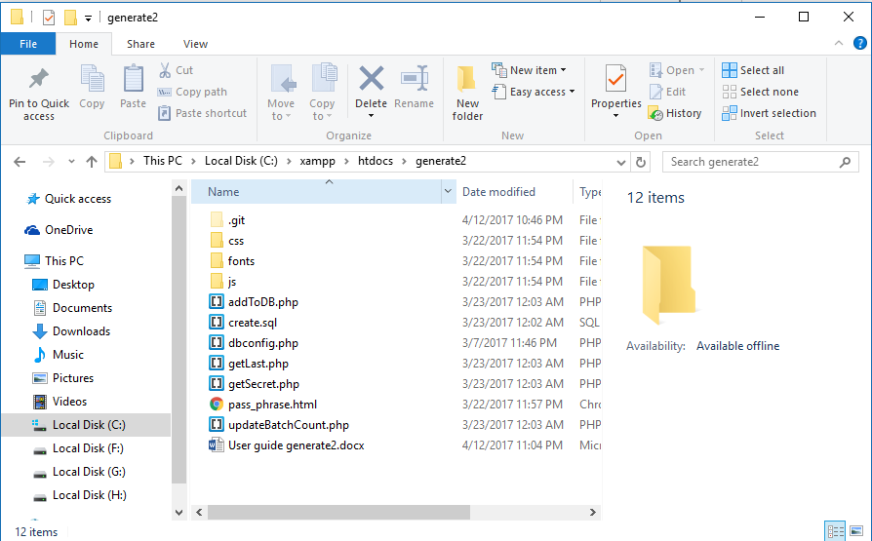
4. Launch Apache and MySQL from Xampp control panel.

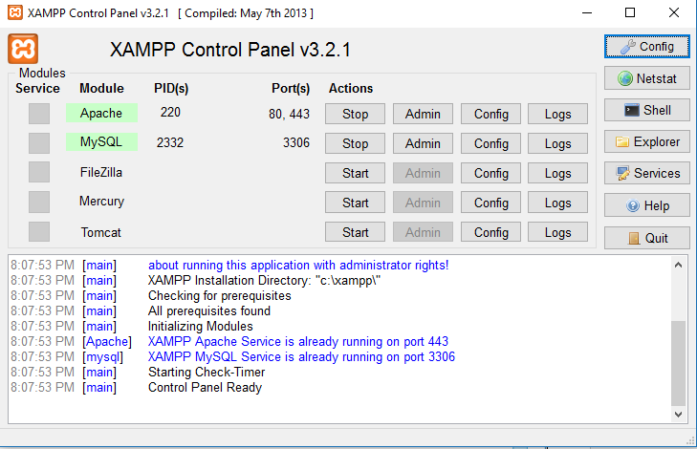

1. Navigate to localhost/phpmyadmin on a browser (on host machine) and click on the SQL tab

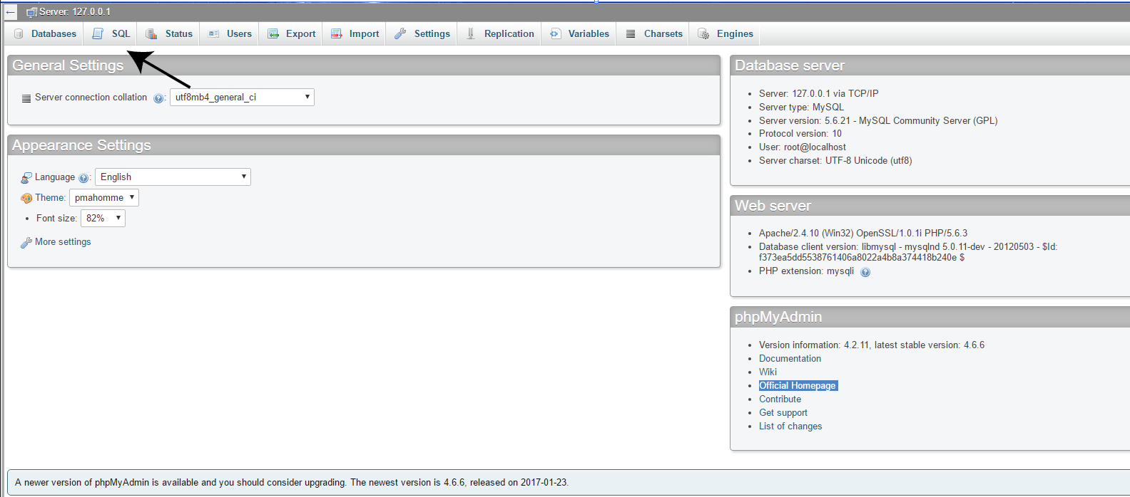

1. Copy the content from C:\xampp\htdocs\generate2\create.sql and paste it inside the text field. Then press go to create the table. (This instruction assumes you have created the atos database by following the steps to get **generate1** working )  
     
   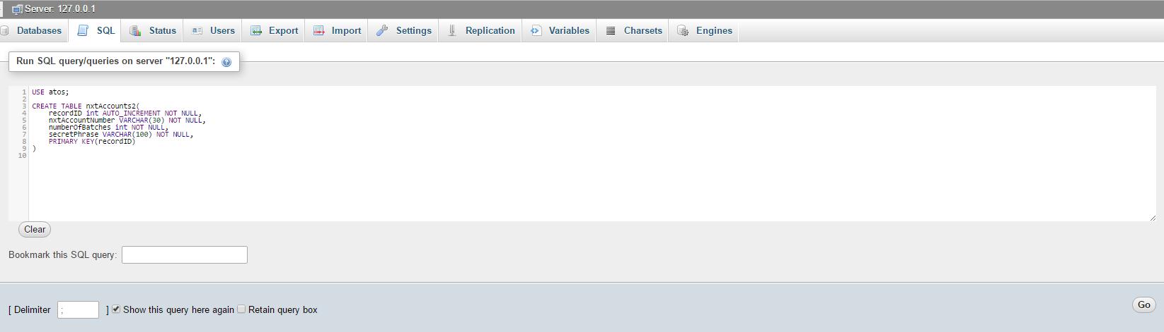
2. Navigate to <http://localhost/generate2/pass_phrase.html>. The web application should be loaded and everything should work well.
3. Should the mySQL database have a non-default username and password, change them in dbconfig.php.

**Open source libraries used:**

* Javascypt - <https://www.fourmilab.ch/javascrypt/pass_phrase.html>
* QR generator - <https://davidshimjs.github.io/qrcodejs/>

**External API used:**

NXT API - <https://nxtwiki.org/wiki/The_Nxt_API>

**Files to take note of:**

* Controller.js in the js folder – It contains most of the logics of the web application. The rest of the JavaScript files are merely dependencies for some libraries to work.

**Use Case:**

1. A worker has 60 apples, and divide them into packs to 6, ending up with 10 packs in total.
2. The worker proceeds to generating the QR for this batch of 60 apples using the ***generate web application*** (FoodChain- Product QR Generator). The QR generated will be printed and placed on each of the 10 packs to signify they are from the same batch.
3. Following that, the worker will proceed to generate a **Transaction QR** using the ***generate2 web application* (**FoodChain – Account Generator**).** After all the 10 packs of apples are placed in a big box for transportation purposes, this transaction QR will be placed on the big box. The product QR will also be on big box.
   * The functions of the Transaction QR are as follows:
     1. To contain NXT account which is to be able to make transactions (send messages to the “vessel” by scanning the product and transaction QR)
     2. When the Transaction QR is scanned using the PreConsumer app, it will query the local database for the secret phrase via WiFi.

**Screenshots of usage:**  
If the database(atos) and table (nxtaccounts2) has been created, this pass_phrase.html should look like this when loaded on a browser (password has been generated).  
  
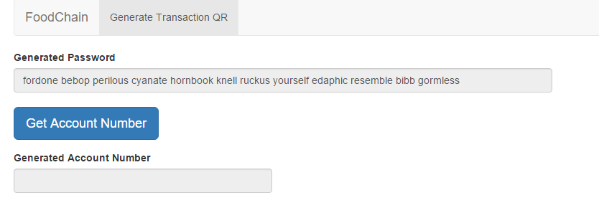

Clicking on the get account number button will create a NXT account using the generated password. If successful, will display the generated account’s number. NXT currency will then be sent to this account (50 at the moment as the NXT testnet did not give us a big amount to test with and thus we will only give a small amount to each testing account) from a main account where all NXT which we are given are stored.   
  
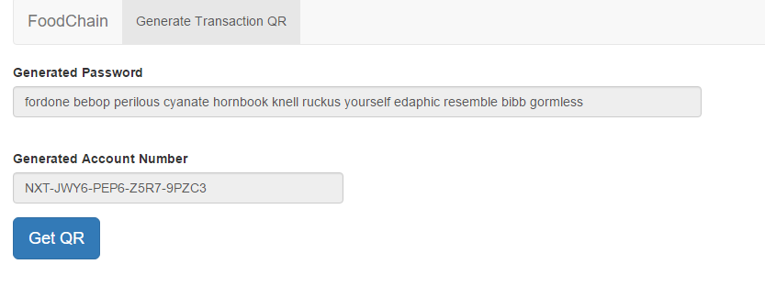

When clicking on the get QR button, one will be greeted with this message prompt. This is because if the user proceeds to repeatedly use the QR without refreshing the page, the amount of NXT available might not be enough to cater for more batches (refer to below).   
  
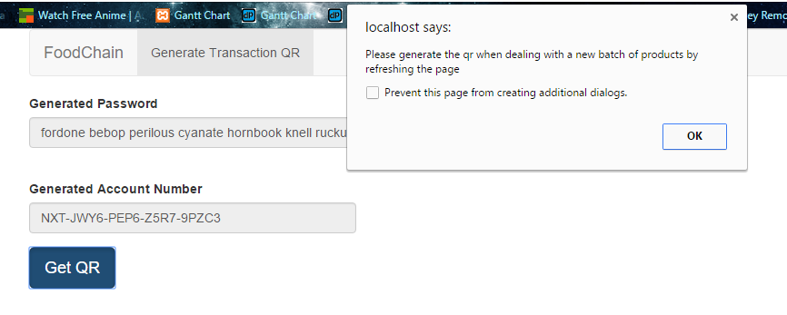

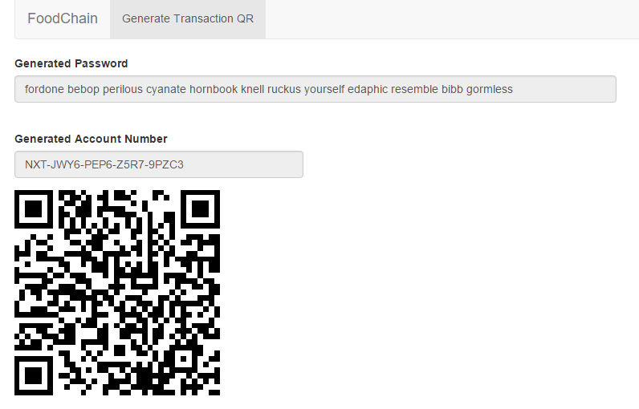

Due to the limited number of NXT coins provided to us, and the amount of transactions which might possible be done on one account (3-4 location * 4 transactions * 4-5 coins per transaction (depending on block height)) = 50-60 NXT. Thus for every batch of products, there will be one account for it (instead of having many batches in one account).  
  
